**CHEAT SHEET:**

Qualitative insights on materials decisions | THIMBY Team 2015

**GENERAL RECOMMENDATIONS**

1. Buy products and construction materials second hand.
   1. Habitat ReStore
   2. Berkeley Outlet
   3. Thrift Stores
2. Simply Google “sustainable [INSERT PRODUCT NAME].”
   1. Rely on research and not company websites that may be “greenwashing.”
3. As a general rule of thumb, use wood and wood-based products in the construction process rather than metals.
   1. Utilize the resources provided by the Environmental Protection Agency to help source wood suppliers that abide by the various silviculture standards and practices.
4. Renewable plant materials such as bamboo, cork, straw, dimension stone, recycled stone and recycled metal are sustainable materials are great green alternatives as well.
5. In terms of waste-water infrastructure, use a recirculating system for centralized hot water distribution. You can do this by incorporating a rainwater runoff harvesting system that gets circulated within the existing infrastructure of the home.
6. Minimize waste by using materials that can be repurposed within your house after their primary use. What cannot be used for your purposes, may be useful to other builders and therefore should be taken to resale stores after the construction processes as landfill is very damaging to many materials over the years.
7. Maximize natural lighting to reduce energy use. This can be done by carefully balancing the need for windows and translucent sheeting.

**I.Electrical:**

**Fan:** When selecting fan size (AE3-43”, AE3-50”, and AE3-60”), first consider space dimensions. The schematic below can aid in your decision-making process.

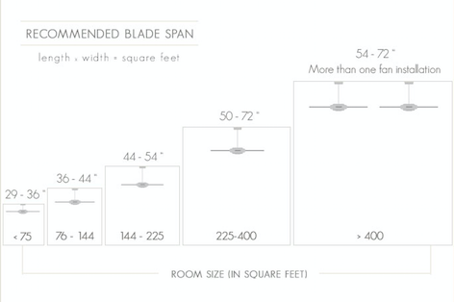

[Source](http://www.delmarfans.com/educate/basics/what-size-ceiling-fan-do-i-need/)

**Solar PV:**

* Due to tighter regulations and lower electrical carbon intensity, p**anels manufactured in the US, Japan or Europe have lower** associated **emissions** and thus energy payback period **than an identical panel manufactured in China.**

[Source](http://www.resilience.org/stories/2015-05-11/how-sustainable-is-pv-solar-power)

* The energy payback period for Chinese panels is roughly twice as long as that of panels manufactured in Europe. Because of the similar carbon intensity of electricity in Europe and USA, American-made panels will have a similar if slightly longer payback period.

[Source](http://www.sciencedirect.com/science/article/pii/S0038092X14001935)

**Batteries:**

* **Lithium Ion** batteries **are** a **better** choice than lead acid **for minimizing carbon impact** in part because they have such a smaller mass, and last much longer. Because Li-Ion batteries don’t need to be replaced nearly as often they have an advantage from a LCA perspective.
* From a cost perspective, the lack of replacement cost and maintenance that come with Li-ion are also a huge benefit. Specifically **the Tesla PowerWall is very well integrated, and the cells are optimized for long life and deep discharge.**

**II.Structure:**

**Framing:**

* For wood framing, using FSC certified wood is a more environmentally friendly. FSC Certified wood is wood certified by the Forest Stewardship Council and comes from a forest managed responsibly. Certified wood does tend to be more expensive.

**Insulation:**

* **Plant based polyethylene** foams are regarded as one of the least carbon intensive materials. However, there is not enough quantifiable data for the embodied carbon so we did not include it in the database.
* **Wool, Cotton, and Cellulose** are all considered greener options. For specific magnitudes, refer to the calculator.
  + cotton, unlike fiberglass, does not contain formaldehyde.

[Source](http://www.cellulose.org/CIMA/low_carbon_footprint_homes.php)

**III.Plumbing:**

**Pipes:**

* PEX piping is 65% less carbon intensive than Copper, this is measured in terms of its global warming potential in the schematic below.

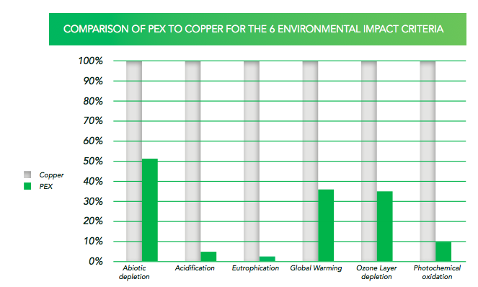

[Source](http://www.greenspec.co.uk/building-design/embodied-energy/)

**IV. Interior:**

**Flooring:**

* **Carpet, Cork, and bamboo** are greener options. The more organic and less processed the material is, the less carbon intensive it is.

[Source](https://www2.buildinggreen.com/article/embodied-carbon-measuring-how-building-materials-affect-climate-0?ip_login_no_cache=8bba001fa5baedc0ed7565ef0dd764b5)

**Kitchen:**

**Cabinets:**

* In order to reduce the embodied carbon within drawers, and cabinets, it is advisable to decrease the amount of board materials and metal within the product.

[Source](http://www.delmarfans.com/educate/basics/what-size-ceiling-fan-do-i-need/)

**Refrigerator:**

* The variability in carbon intensity between refrigerators stems from the use of HFC-245fa (pentafluoropropane). The global warming potential of 1 gram of HFC-245fa is approximately 900 times as high as CO2. Therefore, to reduce the carbon intensiveness of the refrigerator, it is pertinent to choose an appliance with the lowest amount of this chemical.

[Source](http://www.researchgate.net/publication/275218837_A_life-cycle_assessment_of_household_refrigerators_in_China)

* Alternative refrigerant to pentafluoropropane include other hydrocarbons such as:
  + isobuteane (R-600a)
  + propane (R-290), and propylene (R-1270)
  + ammonia (R-717)
  + Carbon (R-744)

[Source](http://www3.epa.gov/ozone/downloads/EPA_HFC_ComRef.pdf)

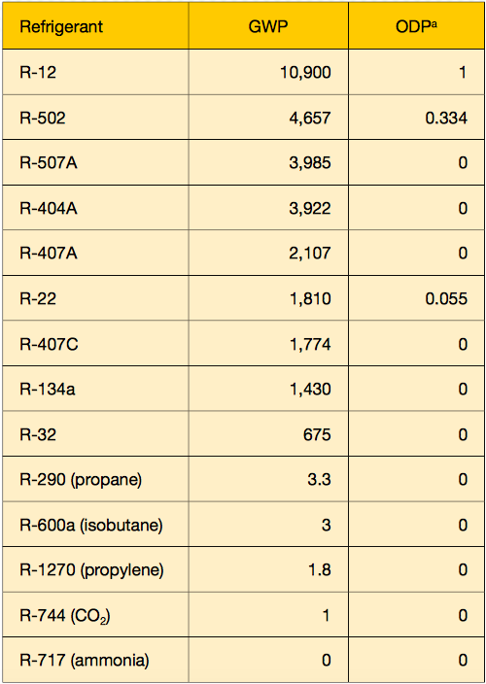

**Furniture:**

**Bed:**

* Mattress: The greatest variation in carbon impact was found out to be in the foams and in the fillings.
* The amount and type of foam/filling used with larger amounts of filling causes the carbon footprint to be higher. Thus, you should **choose the least dense mattress**.
* In terms of the specifics of fillings, the ranking **from least to greatest carbon** intensive includes: **cotton, felt, polyester, followed by wool.**

*Note: polyster filling is more commonly used than cotton. Many mattresses are also made up of a blend between polyester and cotton, if that is the case, to reduce the carbon footprint of the mattress, it is necessary to **increase the percentage of cotton in order to increase efficiency.**

* If deciding between polyurethane and visco-elastic foam, it has been researched that **polyurethane has a lower footprint than visco-elastic** by 20%, assuming that both are the same weight.

[Source](https://www.fira.co.uk/document/fira-carbon-footprinting-document-2011.pdf)

**Chairs:**

* The greatest variation in the carbon emissions between different chairs depends on the extent of its upholstery. Thus, to reduce carbon intensity, it is necessary to **choose chairs with** the **least upholstery**.
* Additionally, chairs with more metal components may give a longer lifespan than plastic materials, therefore **choose chairs that are less plastic intensive.**

[Source](https://www.fira.co.uk/document/fira-carbon-footprinting-document-2011.pdf)

**Sofa:**

* Similarly with chairs, it is essential to **reduce upholstered raw material** content with the chosen foams and fillings.
* Similarly with beds, if deciding between polyurethane and visco-elastic foam, it has been researched that **polyurethane has a lower footprint than visco-elastic** by 20%, assuming that both are the same weight.

**V. Exterior:**

**Roofing:** [Onduvilla®](http://onduvilla-usa.com) is a good alternative to normal shingles

**Windows:**

* A more carbon efficient building material for windows includes using wood/timber as a substitute for aluminum. The below schematic shows that using wooden framework can reduce your emission by about 7.71 metric tonnes of CO2.

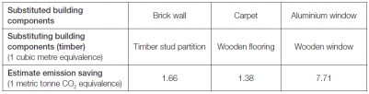

[Source](http://www.climatetechwiki.org/technology/carbon-sink-and-low-carbon-building-materials)